**EXERCISE**

Q1. - Write Java code to define List. Insert 5 floating point numbers in List, and using an iterator, find the sum of the numbers in List.

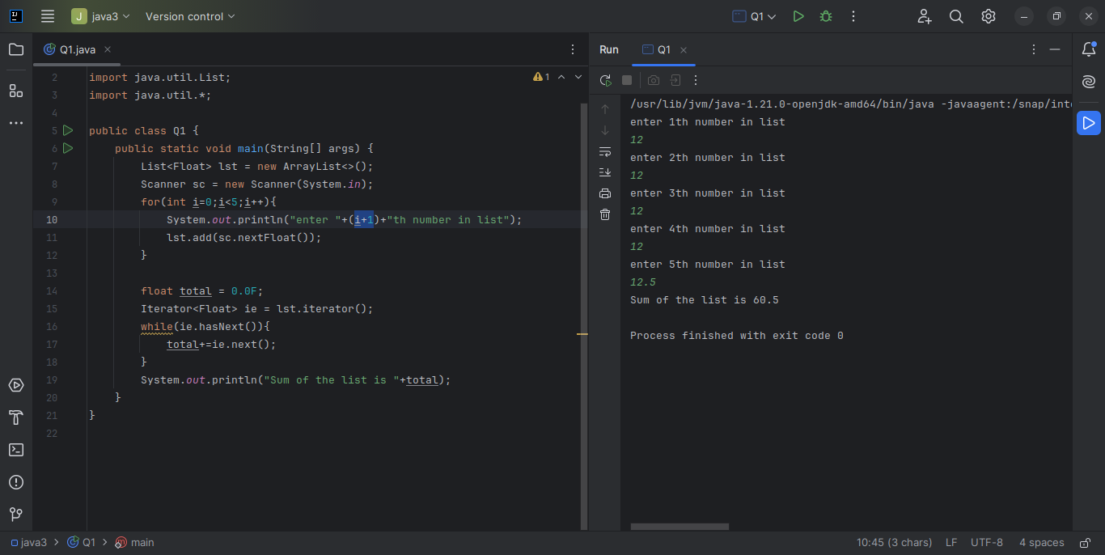

Q2. - Given the following class Employee class{ Double Age; Double Salary; String Name} Design the class in such a way that the default sorting should work on firstname and lastname. Also, Write a program to sort Employee objects based on salary using Comparator.

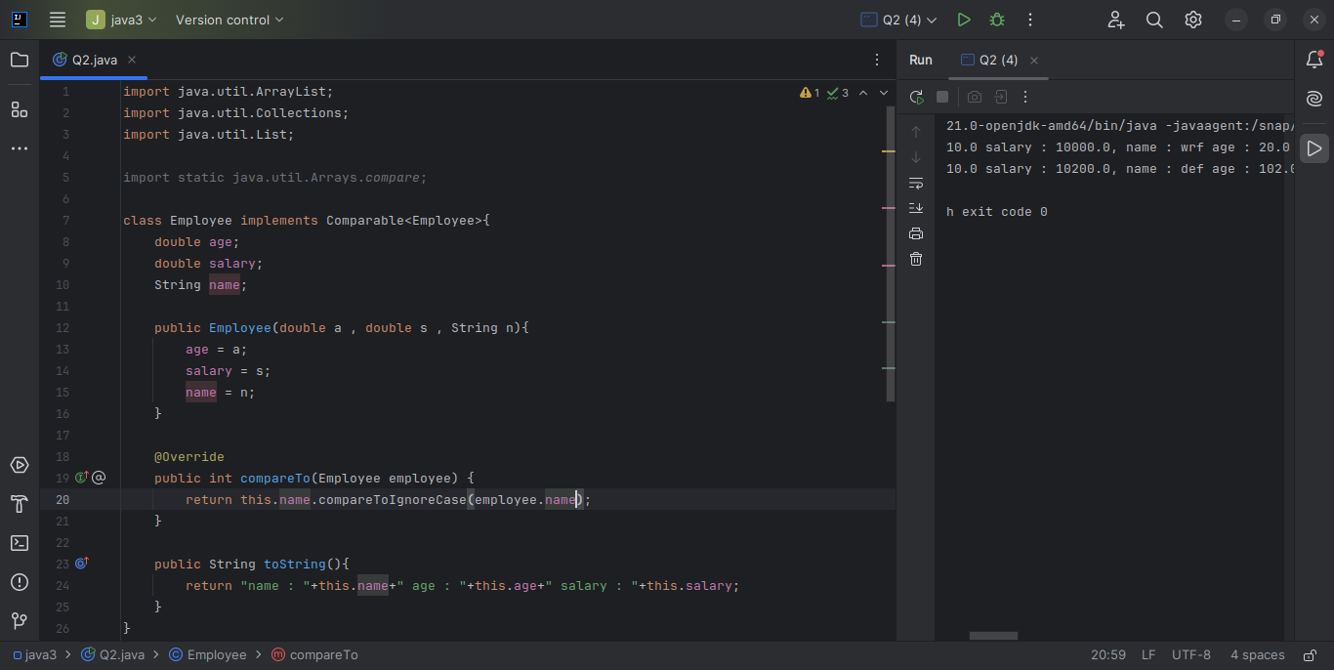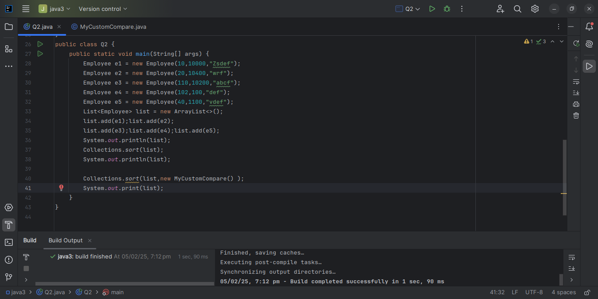

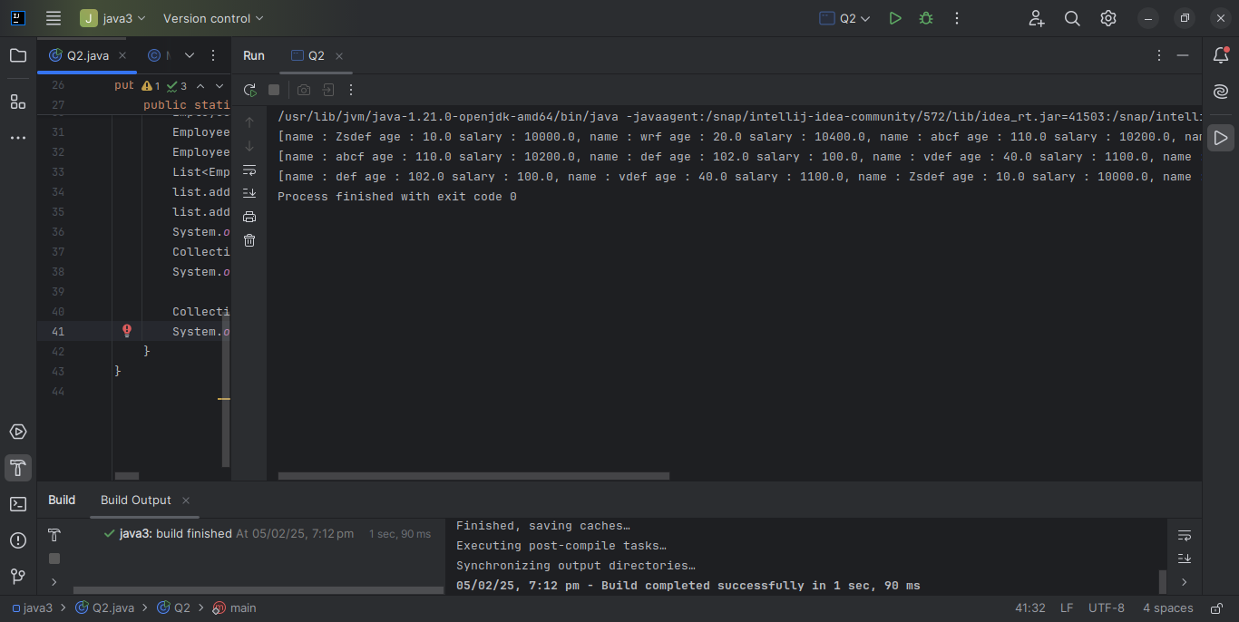

Q3. - Design a Data Structure SpecialStack that supports all the stack operations like push(), pop(), isEmpty(), isFull() and an additional operation getMin() which should return minimum element from the SpecialStack. (Expected complexity ­ O(1))

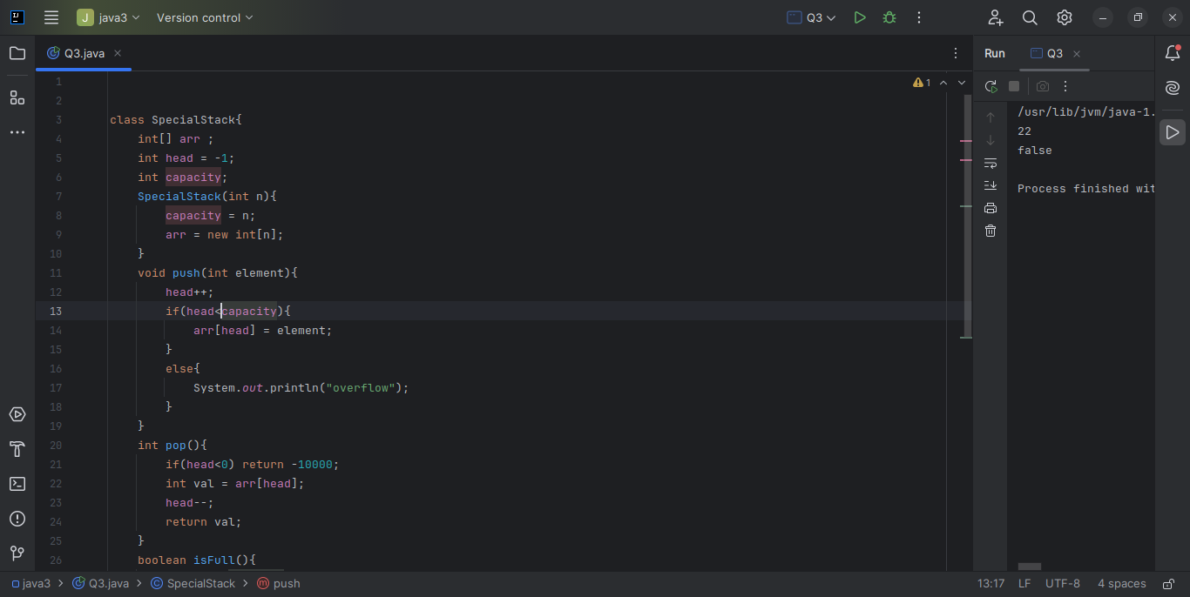

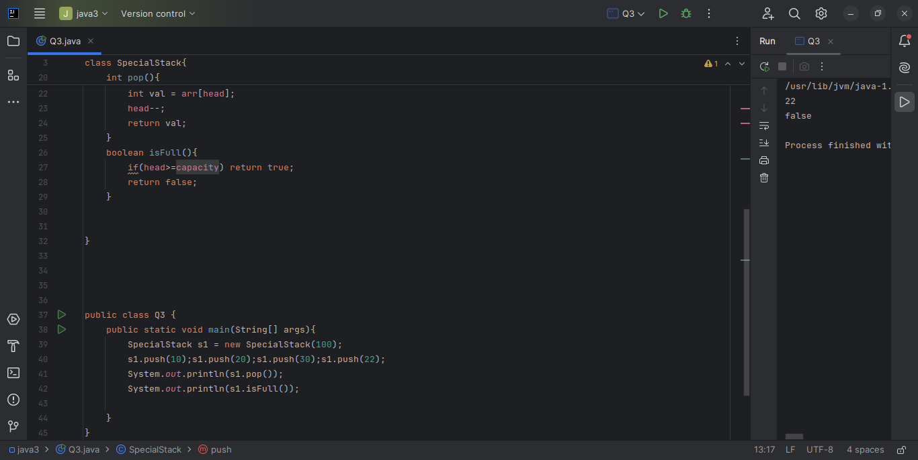

Q4. - Create class Employee with attributes name,age,designation and use instances of these class as keys in a Map and their salary as value

